Step 2: Creating a Data Set:

Topic Selection:
For this project, the selected topic is 7th-grade student performance on math assessments, with a focus on analyzing student responses and feedback related to test questions. This topic was chosen from an educational perspective, as understanding how students interpret and respond to math problems can provide valuable insights into learning gaps and instructional effectiveness.
As education increasingly incorporates data-driven decision-making, analyzing student-generated text such as written explanations, feedback, or common errors can help educators identify patterns in misunderstanding and adjust teaching strategies accordingly. This makes the topic highly relevant for applying text mining techniques to uncover trends in student learning behaviors.
Background:
Mathematics education at the middle school level plays a critical role in developing foundational problem-solving and analytical skills. However, many students struggle with key concepts such as fractions, ratios, and algebraic reasoning. Teachers often rely on test results and written responses to assess student understanding, but these responses are typically unstructured and difficult to analyze at scale.
Text mining provides a method for transforming these unstructured student responses into structured data that can be analyzed systematically. By examining patterns in student language, common errors, and recurring themes in explanations, educators can gain deeper insights into areas where students face challenges. This approach supports more targeted instruction and improved learning outcomes.
Step 3 Build Model:
The goal of this model was to apply text mining techniques to student responses in order to identify patterns in understanding and group similar responses based on vocabulary and themes. The hypothesis was that responses reflecting similar misconceptions or levels of understanding would be clustered together.
The modeling process began by importing the text documents using the Process Documents from Files operator, which converts unstructured text into a structured format. Several preprocessing steps were applied, including tokenization to break text into individual words, stopword removal to eliminate non-informative terms, and case normalization to ensure consistency by converting all text to lowercase.
Following preprocessing, the k-means clustering algorithm was applied to group documents based on similarity in word usage. Clustering was selected as an appropriate method because it is an unsupervised technique that does not require predefined labels. The number of clusters (k) was set to 2, reflecting the expectation that responses would group into categories such as stronger understanding and common misconceptions. Overall, this modeling process demonstrates the application of preprocessing and clustering techniques to extract meaningful patterns from unstructured educational data.
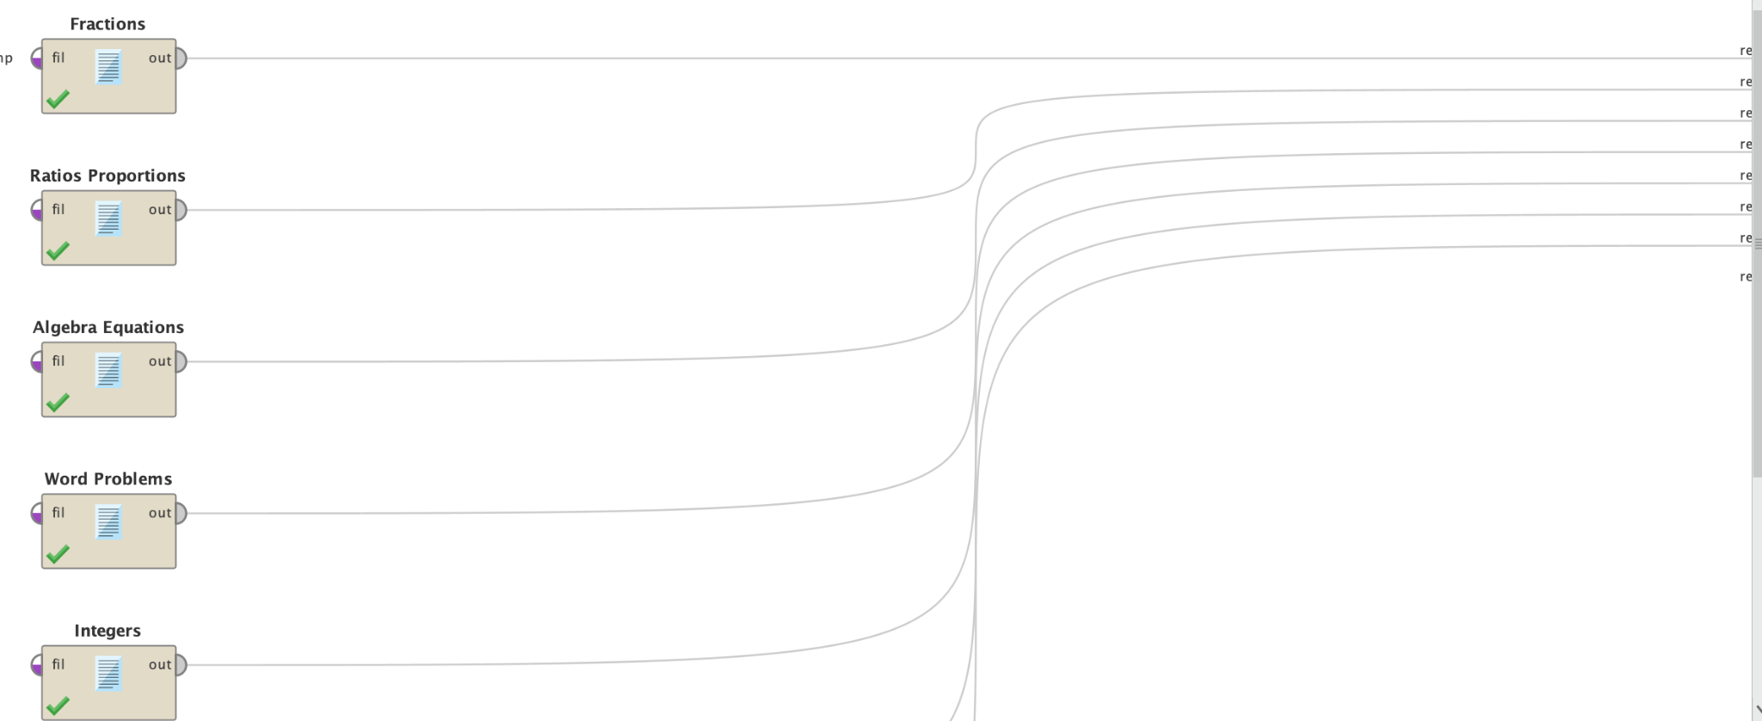

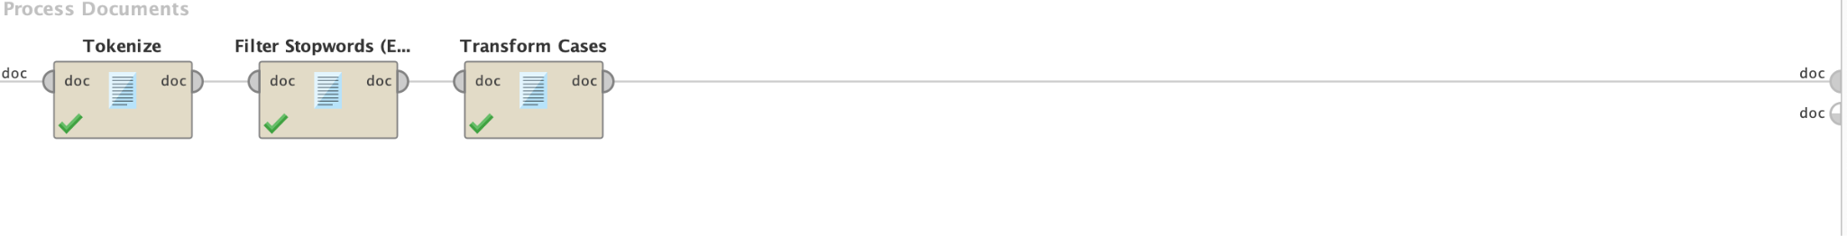

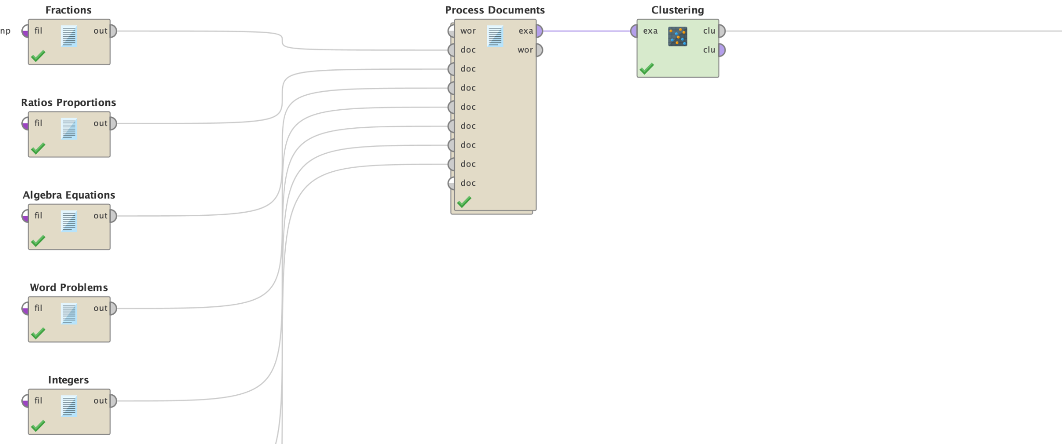

Step 4 Evaluation:
The evaluation of the text mining model focused on determining whether the clustering results successfully supported the original hypothesis. The hypothesis for this project was that student responses demonstrating similar levels of understanding or similar misconceptions in 7th-grade mathematics would be grouped together based on shared vocabulary and patterns in their written explanations.
The results of the k-means clustering model indicated that the documents were grouped according to similarities in word usage and themes. For example, responses that frequently included words such as “confusing,” “trouble,” “mistake,” and “forgot” were grouped together, suggesting a cluster representing students experiencing difficulty or misunderstanding. In contrast, documents containing terms such as “understand,” “practice,” and “correct” were grouped into a separate cluster, representing stronger comprehension of the material. These groupings suggest that the model was able to successfully identify patterns in student learning and partially support the original hypothesis. I learned how unstructured textual data can be transformed into meaningful insights using text mining techniques. By analyzing student responses, educators can identify common misconceptions and adjust instructional strategies accordingly.

